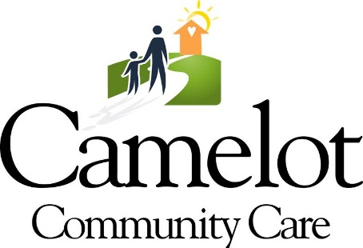

4910-D Creekside Drive, Clearwater, FL 33760
727-593-0003 * www.camelotcommunitycare.org

Dear Valued Community Partner:

I am writing regarding Camelot Community Care’s upcoming annual charity golf classic. This year the golf classic will be held on Friday, October 15th at Westchase Golf Club. This fun community awareness event attracts between 120 and 140 golf participants. The event committee and I invite you to support this event and, most importantly, the work that we do daily for nearly 7,000 children who may be experiencing the trauma and neglect throughout Florida.

Your thoughtful consideration of a donation for our silent auction, will ensure that vital financial support will be given to support the programs serving the unaccompanied homeless youth right here in the Tampa Bay area. In exchange for your generous donation, your company will be marketed to the event participants and the donation is tax deductible. It is our hope that you will consider a donation for this year’s tournament.

Camelot’s mission is to enable children and families to realize their fullest potential by stopping the cycle of abuse and neglect in families and in our community. The 2021 Golf Classic proceeds will benefit Camelot’s programs that provide support services to homeless youth, foster children & young adults, and adoptive families. These life-changing programs help to fulfill dreams of a brighter future. No child should ever have to recover from their childhood however, you can join us in keeping children safe and creating a bright future for our most important resource.

With your help, Camelot Community Care will continue to lead the way in improving the quality of lives for all of the children and families we serve. Please join us in our efforts to triumph over children experiencing abuse, neglect or behavioral issues by contributing an item to the Camelot Community Care Golf Classic.

Your generous donation can be mailed to the Camelot Office at 4910-D Creekside Drive, Clearwater, FL 33760 Attn: Rebecca Payne – Chief Development Officer or kindly call or email with the information below to coordinate pick-up of the item. Please be sure to complete the value form and return with your donation. We would appreciate donations in hand no later than Wednesday, September 29, 2021.

Please plan to be a part of the October 15th event and help change a lifetime for the children and families in the foster care system that we serve! I look forward to your support! For your records, the organization’s Tax ID number is attached. Thank you for your consideration!

All my best,

Rebecca Payne

Rebecca Payne
Chief Development Officer
407.607.6272 (Cell)
rpayne@camelotcommunitycare.org

